**Assignment-4**

**1. Create a stored procedure in the Northwind database that will calculate the average value of Freight for a specified customer.Then, a business rule will be added that will be triggered before every Update and Insert command in the Orders controller,and will use the stored procedure to verify that the Freight does not exceed the average freight. If it does, a message will be displayed and the command will be cancelled.**

alter proc sp_avg_freight

@customerID varchar(10), @avgval float output

AS

BEGIN

-- Calculate the average Freight for the specified customer

select @avgval=AVG(Freight)

FROM porders

WHERE CustomerID = @customerID

return @avgval

END

alter trigger [dbo].[AverageFreightValidation]

ON [dbo].[Porders]

after INSERT, UPDATE

AS

BEGIN

set nocount on

DECLARE @avgval float,

@customerID varchar(10),

@Freight real

select @customerID = CustomerID,

@Freight= Freight

from inserted

EXEC sp_avg_freight @customerID , @avgval OUTPUT

IF (@Freight > @avgval)

BEGIN

RAISERROR('Freight exceeds the average freight', 16, 1)

ROLLBACK TRANSACTION

END

END

**Execution:-**

SET IDENTITY_INSERT Porders ON

Go

--delete from porders where OrderID = 11081

INSERT INTO Porders (OrderID, CustomerID, EmployeeID ,OrderDate, RequiredDate,"ShippedDate","ShipVia","Freight" ,"ShipName","ShipAddress","ShipCity","ShipRegion",ShipPostalCode, ShipCountry)

VALUES(11081, 'RATTC',1, NULL, NULL, NULL, 2,

80000, 'Rattlesnake Canyon Grocery','2817 Milton Dr.',

'Albuquerque', 'NM', 87110, 'USA')

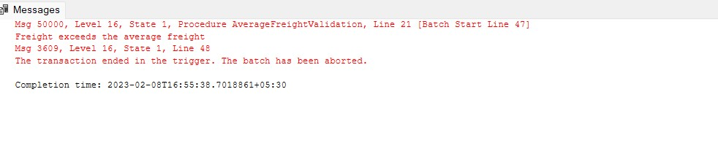

**2. write a SQL query to Create Stored procedure in the Northwind database to retrieve Employee Sales by Country**

alter proc spemployeesalescountry

@shipcountry nvarchar(40)

as

begin

select EmployeeID,sum(Quantity) as sales

from Porders P

right join "Order Details" O

on P.OrderID = O.OrderID

where ShipCountry = @shipcountry

group by EmployeeID

end

**Execution:-**

spemployeesalescountry USA

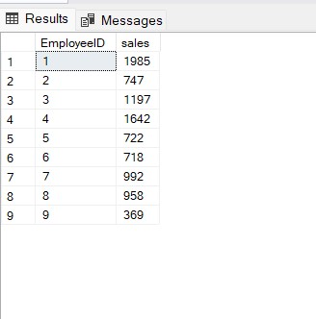

**3. write a SQL query to Create Stored procedure in the Northwind database to retrieve Sales by Year**

alter proc spemployeesalesYear

@shipyear datetime

as

begin

select count(OrderID) as salesbyyear from Porders where Year(OrderDate) = @shipyear

end

**Execution:-**

spemployeesalesYear 1997

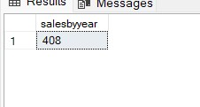

**4. write a SQL query to Create Stored procedure in the Northwind database to retrieve Sales By Category**

alter proc spemployeesalesCat

@category nvarchar(40)

as

begin

select count(OrderID) as salesbycategory from [dbo].[Porders] where OrderID in (

select OrderID from [Order Details] where ProductID in (

select ProductID from Products where CategoryID IN (

select CategoryID from Categories where CategoryName = @category)))

end

**Execution:-**

spemployeesalesCat Seafood

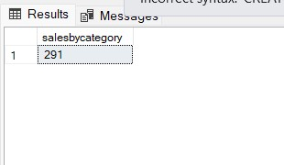

**5. write a SQL query to Create Stored procedure in the Northwind database to retrieve Ten Most Expensive Products**

create proc spmostexpensive

as

begin

select top 10(ProductName),UnitPrice from Products order by UnitPrice desc

end

**Execution:-**

spmostexpensive

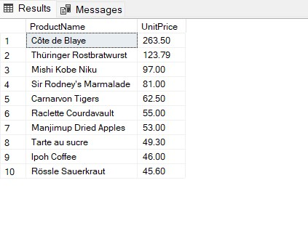

**6. write a SQL query to Create Stored procedure in the Northwind database to insert**

Customer Order Details

create procedure spGetInsertCustomerOrderDetail

@orderid int,

@productid int,

@unitprice money,

@quantity smallint,

@discount real

as

begin

insert into [Order Details]

(

OrderID,ProductID,UnitPrice,Quantity,Discount

)

values

(

@orderid ,

@productid ,

@unitprice ,

@quantity ,

@discount

)

End

**Execution:-**

spGetInsertCustomerOrderDetail 10248,5,120,12,0.2

select * from [Order Details]

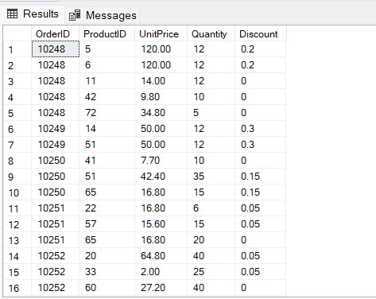

**7. write a SQL query to Create Stored procedure in the Northwind database to update**

Customer Order Details

create procedure spGetUpdateCustomerOrderDetail

@orderid varchar(6),

@unitprice money,

@quantity smallint,

@discount real

as

begin

update [Order Details]

set

UnitPrice=@unitprice,Quantity=@quantity,Discount=@discount

WHERE

OrderID=@orderid

end

**Execution:-**

spGetUpdateCustomerOrderDetail 10249,50,12,0.3

select * from [Order Details]

